How To Use Python For DevOps?
Python is an open-source programming language with immense library support. Some of the features and modules can be used for development in other platforms like Java, C#, etc. In this article, we will learn how Python is used for DevOps and the reasons behind it. The following concepts are covered in this article:
- Reasons For Using Python For DevOps
- How Python and DevOps Work Together?

Reasons For Using Python For DevOps
Python serves as the remedy to any problem in the IT industry. When it comes to DevOps, the main focus or the ultimate goal is to reduce the time taken in the DevOps life cycle to improve efficiency. Python offers a structural solution in terms of automating the tasks in each of the stages in the DevOps life cycle. Considering the out-of-the-box features python comes with, let us take a look at how Python is one of the best suitable options to work with DevOps.
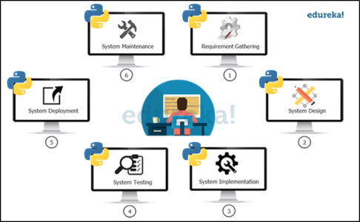
- Python is one of the best scripting languages. The vast variety of python libraries allows us to write scripts for the improved development life cycle.
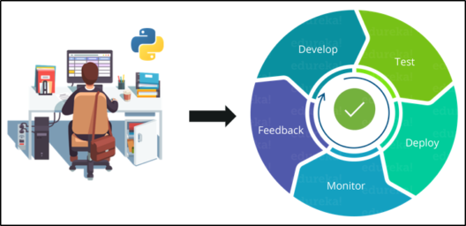
- Python provides structure to write structured and readable automation scripts
- The accessibility and flexibility give python an adaptive feature that results in exploring new tools and technologies without any effort
- When it comes to orchestration and infrastructure automation python is quite useful, even tools like Ansible and SaltStack are written in pure python.
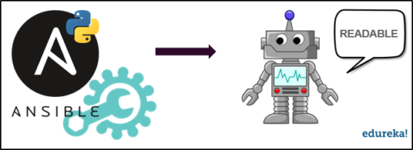
- Due to ease of learning python saves time in building utilities.

- Even though all the tasks that we do with python can be achieved with Ruby, but people still prefer python because of the easy syntax and readability.
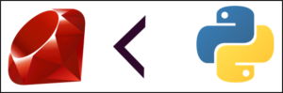


Python Certification Training Course

Master python today to become the leader of tomorrow, Edureka’s Python Programming Certification course will get you on speed in no time. Considering the number of features and advantages that python offers, Let us take a look at how DevOps actually works with python.

How Python And DevOps Work Together?
The ultimate goal with DevOps is to automate each task in the development life cycle to save time. With python modules and libraries we can do automation using the tools and scripts written in python.
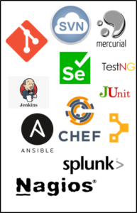
A python automation script is platform-independent and supports multi-tool integration, which makes python a better seeming option.

Here are a few python modules that can be used to write automation scripts for DevOps:
- You can set some useful functions or properties dynamically by writing a python script using the Gitapi module that interacts with the version control system.
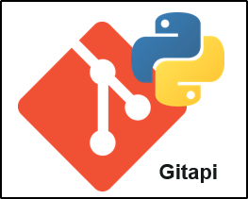
- To be able to move environments, we can use python since we face a problem bash or PowerShell when the CI environment changes.
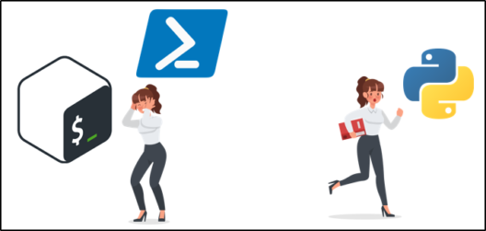
- Python has networking,environment-specific and operating system specific modules like OS and subprocess that can handle these details and methods
- We can implement infrastructure-related automation scripts using python that has their SDKs. boto and google-cloud-storage are the SDK modules for AWS and GCP(Google Cloud Platform) respectively
- Python’s OpenStack modules deal with all the operations in the public and private clouds of OpenStack.
- Configuration management tools like Ansible are written in pure python. So in order to add any more custom modules, we write them in python
- Testing frameworks like Selenium can be used for automation testing using python. Even Django can be used to UnitTests using the built-in testing framework.
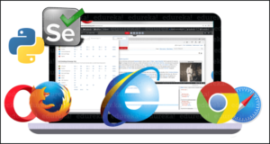
- Python has modules for almost all databases for database management tasks such as MongoDB, MySQL, PostgreSQL, etc.
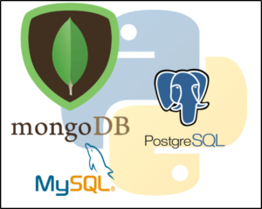
- DevOps uses Python for deployment with modules like fabric, fabtools, cuisine
- In cases of deployment using a platform as a service(Paas), we have a python module called cloudfoundry_client
- The Monitoring stages in the DevOps stages can also be managed by python modules

